**Name – Ujjawal Mandhani**

**Batch – F6**

**Enroll no. - 9918103237**

**OSSP LAB-2**

**Question****1. Create a python script to print hello, world! four times.**

for x in range(0, 4):

print("hello world")

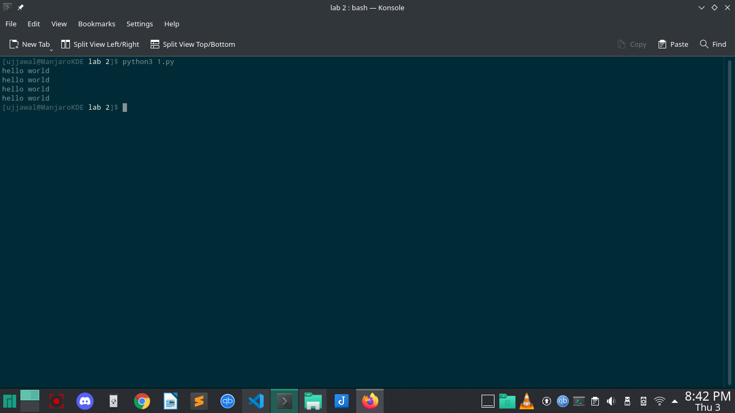

**Question3. Write a function “duplicate” to find all duplicates in the list.**

**l=[1,2,3,4,5,2,3,4,7,9,5]**

l1=[]

for i in l:

if i not in l1:

l1.append(i)

else:

print(i)

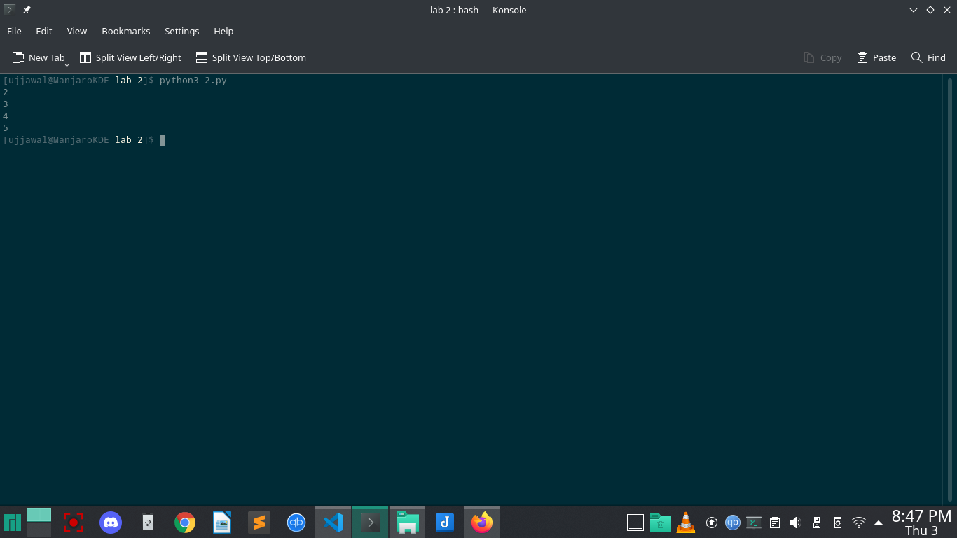

**Question 4: Write a function group (list, size) that take a list and splits into smaller lists of given size.**

**def group(x,l):**

g1=[]

g=[]

i=0

while i<len(x):

if(len(g1) < l):

g1.append(x[i])

i=i+1

else:

g.append(g1)

g1=[]

g.append(g1)

return g

print (group([1,3,2,2,9,7,2,4],3))

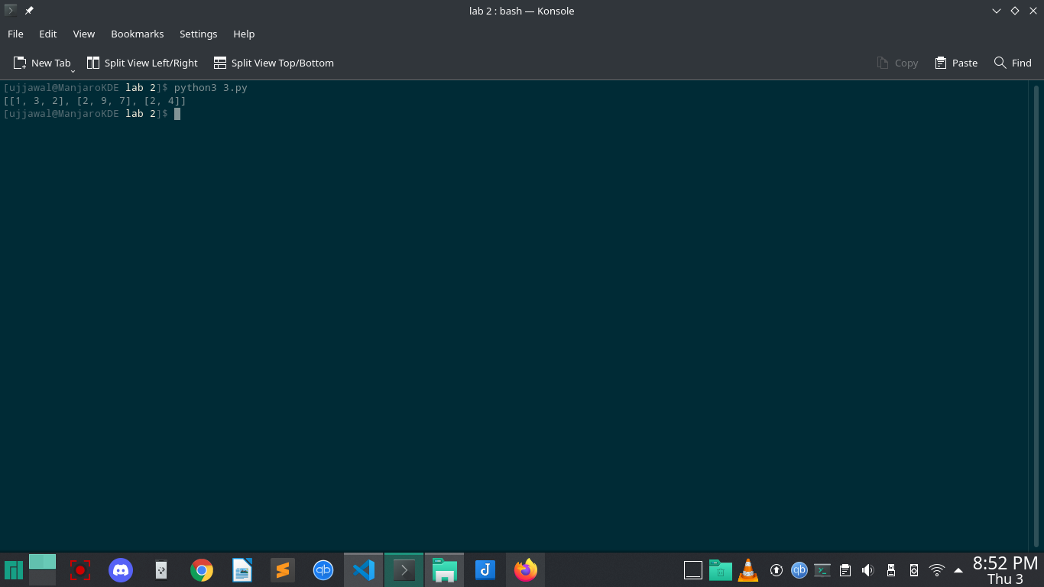

**Question5. Write a function “lensort” to sort a list of strings based on length.**

**def lensort(list):**

list.sort(key=lambda s: len(s))

return list

print(lensort(['python', 'perl', 'java', 'c', 'haskell', 'lisp', 'ocaml', 'smalltalk', 'ruby']))

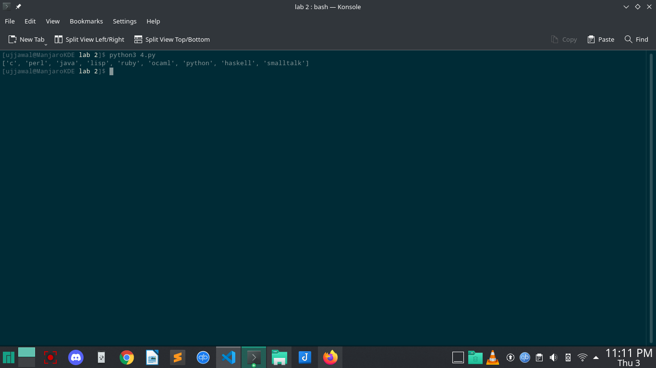

**Question****6. Write a function extsort to sort a list of files based on extension.\**

**def extsort(x):**

i=0

while(i<len(x)):

x[i]=x[i].split('.')

i=i+1

x.sort(key=lambda x:x[1])

i=0

while(i<len(x)):

x[i]=".".join(x[i])

i=i+1

return x

print (extsort(['a.c','a.py','b.py','bar.txt','foo.txt','x.c']))

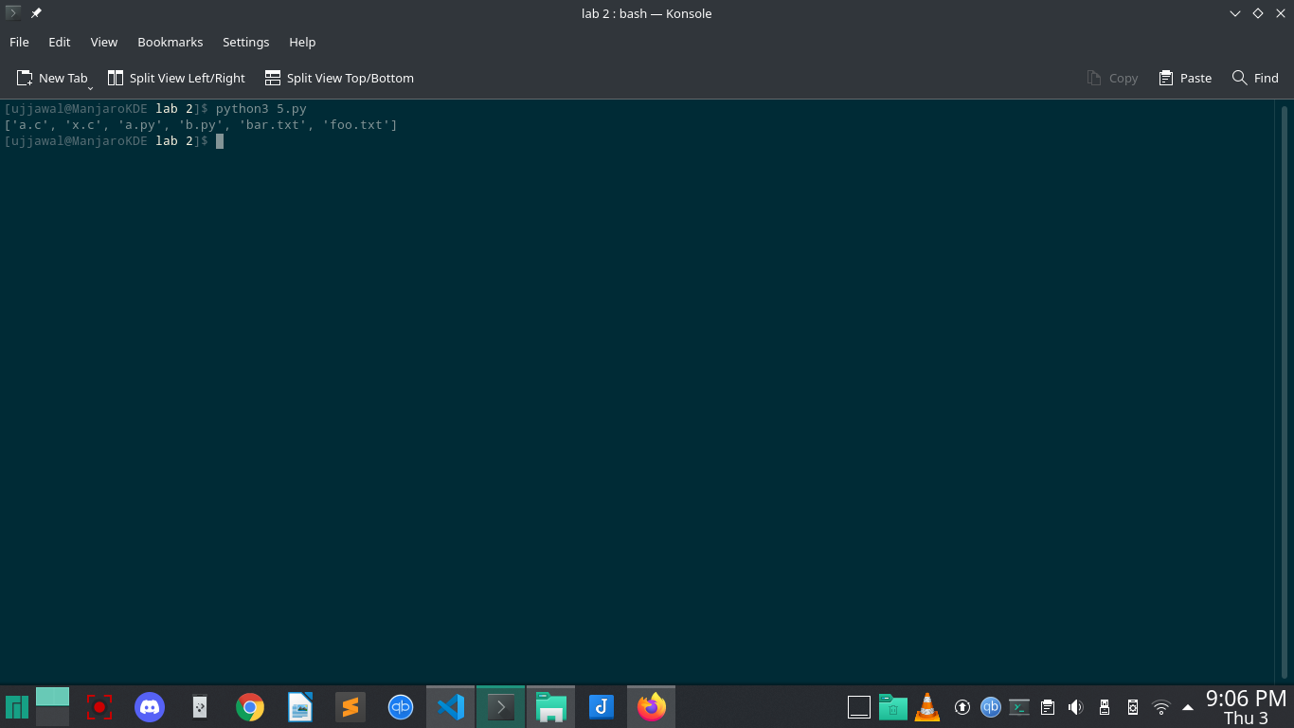

**Question 7:****Use Python Built-in Functions ‘open’, ‘read’, ‘’readline, ‘write’,’writeline’ to work with**

**Files.**

**filename = "test.txt"**

filehandle = open(filename,"w")

filehandle.write("\nNew line")

filehandle.write("\nNew Content")

filehandle.close()

f=open(filename,"r")

while True:

line = f.readline()

if not line:

break

print(line)

f.close()

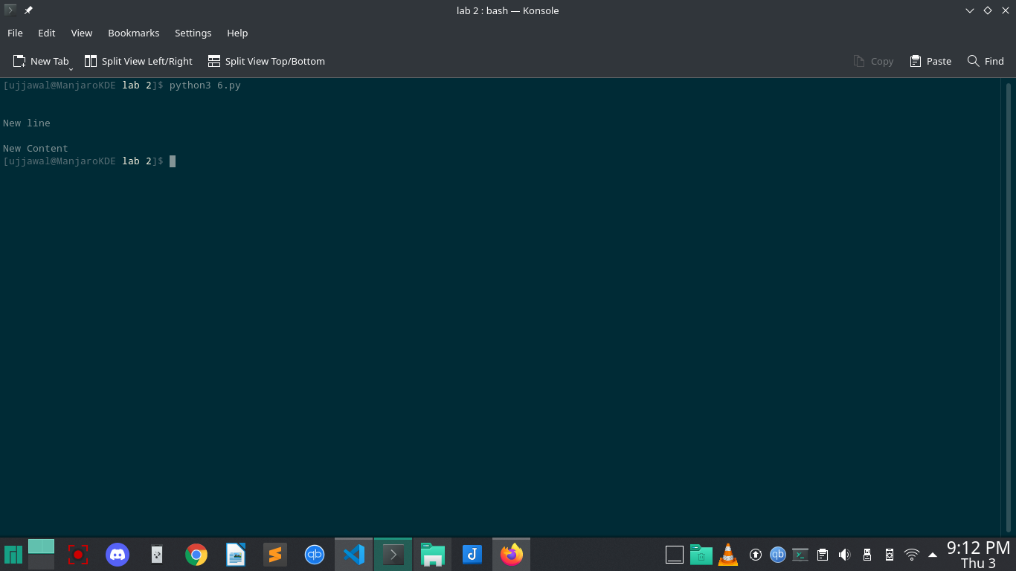

**Question 8: Compute the number of characters, words and lines in a file.**

**def counter(fname):**

num_words = 0

num_lines = 0

num_charc = 0

num_spaces = 0

with open(fname, 'r') as f:

for line in f:

num_lines +=1

word='Y'

for letter in line:

if(letter != ' ' and word == 'Y'):

num_words +=1

word = 'N'

elif (letter == ' '):

num_spaces += 1

word = 'Y'

for i in letter:

if(i !=" " and i !="\n"):

num_charc +=1

print("Number of words in text files ",num_words)

print("Number of lines in text files ",num_lines)

print("Number of characters in text files ",num_charc)

print("Number of spaces in text files ",num_spaces)

if __name__ == '__main__':

fname = 'test.txt'

try:

counter(fname)

except:

print("file not found")

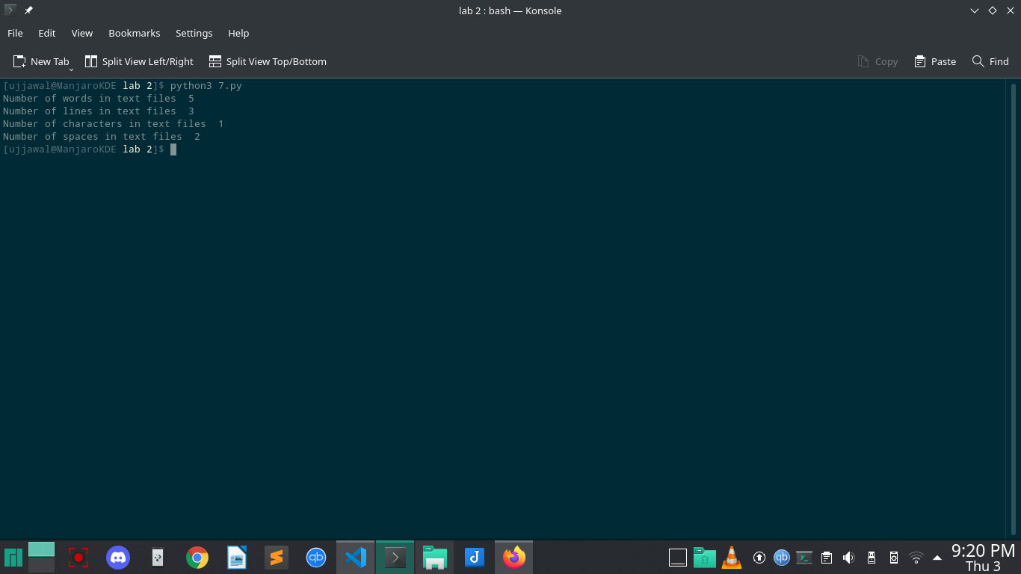

**Question****9. Write a program reverse.py to print lines of a file in reverse order.**

**testfile = open("test.txt")**

lines = testfile.readlines()

for line in reversed(lines):

print(line)

testfile.close()

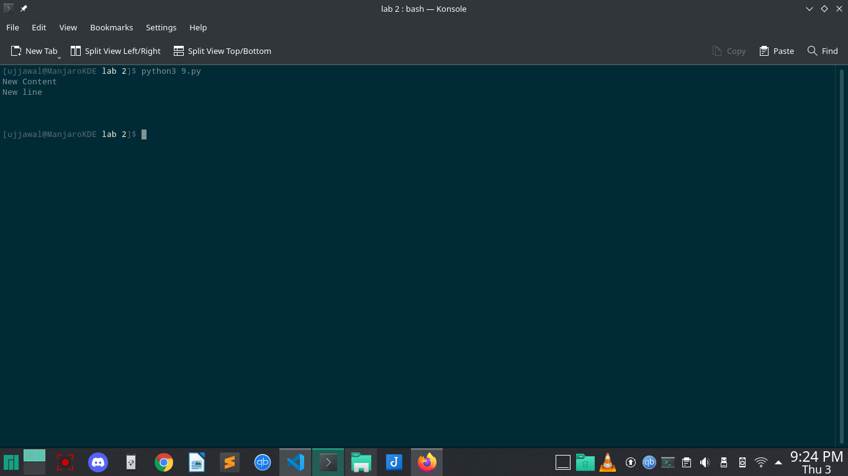

**Question10. Write a program to print each line of a file in reverse order.**

**filename = "test.txt"**

f = open(filename, 'r+')

lines = f.readlines()

for x in lines:

print(x[-1::-1])

f.close()

